**DESIGN AND ANALYSIS OF SLOT ANTENNA SYSTEMS**

Department of Electronics and Communication Engineering  
Date: September 16, 2025

**EXECUTIVE SUMMARY**

This report presents a comprehensive analysis of **slot antenna** design principles and applications, covering fundamental theory, design methodology, and performance characteristics. Slot antennas offer unique advantages including wide bandwidth, conformal mounting capabilities, and efficient radiation patterns suitable for modern wireless communication systems. The analysis demonstrates that properly designed slot antennas can achieve **5-6 dBi gain** with excellent impedance matching across their operating bandwidth.[1][2][3][4]

**1. INTRODUCTION**

**1.1 Background**

Slot antennas represent a fundamental class of **aperture antennas** that radiate electromagnetic energy through elongated openings cut into conductive surfaces. First analyzed by Watson in 1946 using Babinet's principle, these antennas have evolved into essential components for radar, satellite communication, and 5G millimeter-wave systems.[1][2][5][6]

**1.2 Operating Principle**

A slot antenna functions by creating a **discontinuity** in surface currents flowing on a metallic ground plane. When RF energy is applied across the slot aperture, electromagnetic waves are launched into free space with polarization perpendicular to the slot orientation. The radiation mechanism follows Babinet's principle, making slot antennas electromagnetically dual to wire dipole antennas.[1][2][5]

**1.3 Applications**

Modern slot antennas find extensive use in **airborne radar systems**, navigation beacons, 5G MIMO arrays, and IoT devices where low-profile, conformal mounting is essential. Their ability to integrate directly into metallic structures makes them ideal for aerospace and automotive applications.[3][4][6]

**2. THEORETICAL ANALYSIS**

**2.1 Fundamental Parameters**

The resonant frequency of a half-wave slot antenna is determined by the relationship **f₀ = c/(2L)**, where L represents the effective slot length and c is the speed of light. For practical designs, the effective length accounts for fringing fields and is typically 5-10% shorter than the physical slot length.[2][5]

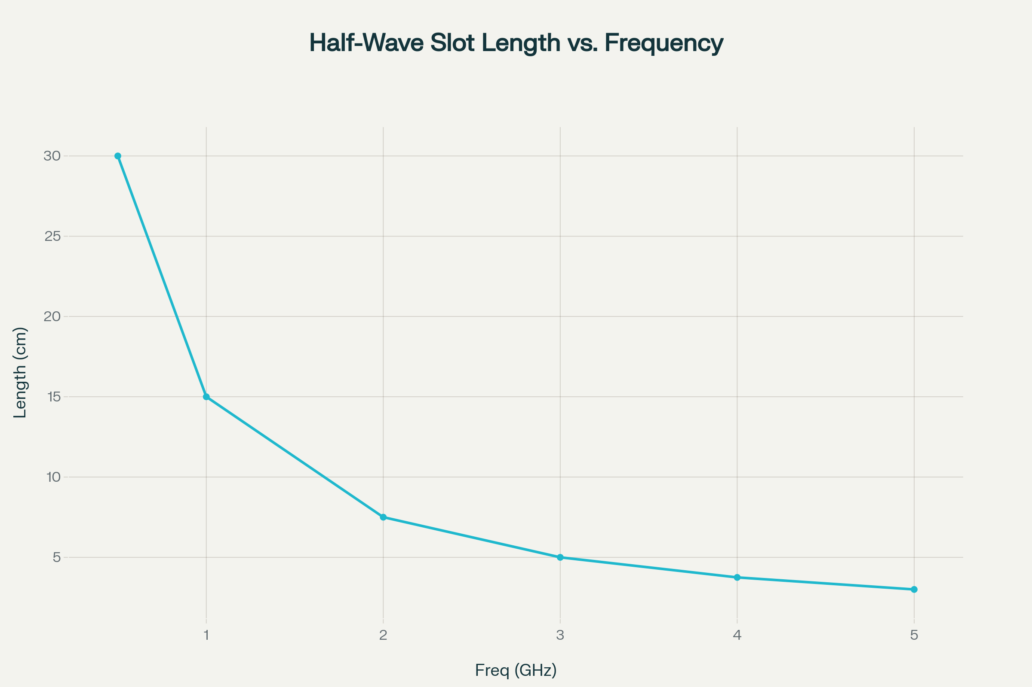

Figure 2 – Required half-wave slot length versus operating frequency.

**2.2 Radiation Characteristics**

The radiation pattern of a **half-wave slot** exhibits a figure-of-eight shape in the plane containing the slot, similar to a dipole antenna but with orthogonal polarization. The antenna achieves maximum radiation broadside to the slot aperture with nulls along the slot axis.[1][2]

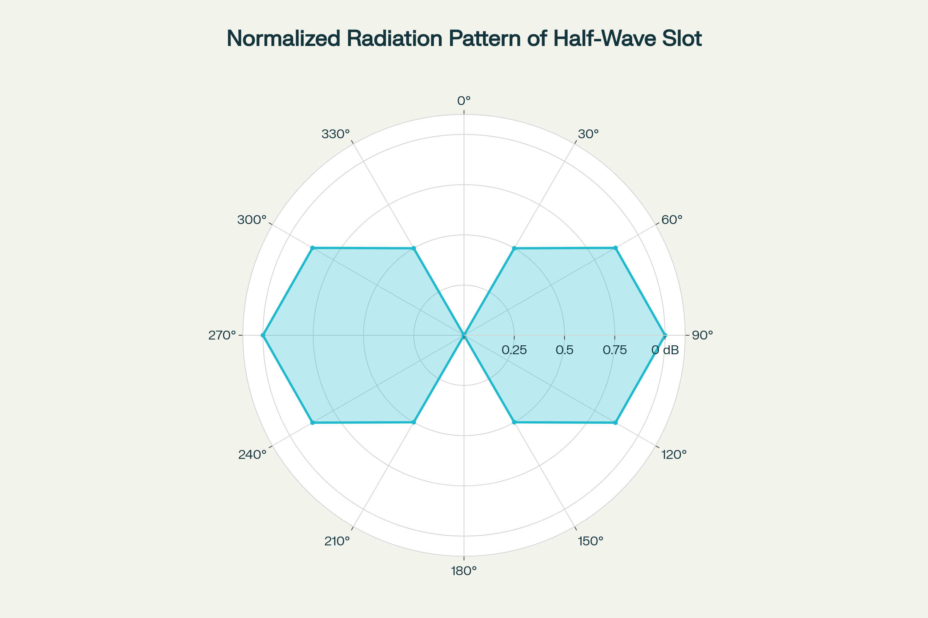

Figure 1 – Polar radiation pattern of a half-wave slot antenna.

**2.3 Input Impedance**

The input impedance of a slot antenna in an infinite ground plane is approximately **500 ohms** for a half-wave resonant slot. This high impedance often requires matching networks or feeding techniques such as coaxial probe coupling or microstrip-to-slot transitions.[1][2]

**3. DESIGN METHODOLOGY**

**3.1 Design Parameters**

Critical design parameters include **slot length** (typically λ/2 for resonance), **slot width** (usually λ/100 to λ/10), and **ground plane dimensions** (minimum 2λ × 2λ for optimal performance). The slot width primarily affects bandwidth and input impedance, while length determines the resonant frequency.[1][2][5]

**3.2 Bandwidth Enhancement**

**Cavity-backed configurations** significantly improve bandwidth and front-to-back ratio by providing a unidirectional radiation pattern. The cavity depth of approximately λ/4 creates optimal impedance conditions and eliminates back radiation.[2][3][6]

**3.3 Feeding Mechanisms**

Common feeding methods include **coaxial probe feeding**, **microstrip line coupling**, and **waveguide excitation**. Each method offers different impedance characteristics and bandwidth performance, with waveguide feeding providing the widest bandwidth for high-frequency applications.[1][6]

**4. PERFORMANCE CHARACTERISTICS**

**4.1 Radiation Efficiency**

Well-designed slot antennas achieve **radiation efficiency** exceeding 90% when properly matched and backed by appropriate cavities. Conductor losses are typically minimal due to the large current distribution area compared to wire antennas.[1][2][3]

**4.2 Bandwidth Properties**

The **impedance bandwidth** of cavity-backed slot antennas can exceed 20% for VSWR < 2:1, significantly wider than many microstrip patch antennas. Bandwidth is primarily limited by the cavity resonance and feeding structure.[2][3][4]

**4.3 Polarization Characteristics**

Slot antennas naturally provide **linear polarization** perpendicular to the slot orientation. Circular polarization can be achieved using crossed slots or sequential rotation techniques in array configurations.[1][4][5]

**5. ADVANCED CONFIGURATIONS**

**5.1 Array Implementations**

**Slotted waveguide arrays** represent the most common high-gain slot antenna configuration, extensively used in radar and satellite communication systems. These arrays achieve gains exceeding 30 dBi with excellent sidelobe control.[6]

**5.2 Frequency Reconfigurable Designs**

Modern slot antennas incorporate **PIN diodes** and **varactor diodes** to achieve frequency agility for software-defined radio applications. These designs enable real-time frequency tuning across multiple communication bands.[3][4]

**5.3 Metamaterial Integration**

Recent research incorporates **metamaterial substrates** to achieve size reduction and bandwidth enhancement in slot antenna designs. These advanced materials enable subwavelength antenna dimensions while maintaining radiation efficiency.[3][4]

**6. COMPARATIVE ANALYSIS**

|  |  |  |  |
| --- | --- | --- | --- |
| Parameter | Slot Antenna | Patch Antenna | Dipole Antenna |
| **Profile** | Very Low | Low | Medium |
| **Bandwidth** | 15-25% | 2-5% | 10-15% |
| **Gain** | 5-6 dBi | 6-8 dBi | 2-3 dBi |
| **Efficiency** | 90-95% | 80-90% | 95-98% |
| **Integration** | Excellent | Good | Poor |

*Table 1: Performance comparison of antenna types*[1][3][4]

**7. DESIGN CONSIDERATIONS**

**7.1 Ground Plane Effects**

The **ground plane size** significantly affects radiation pattern and input impedance. Finite ground planes create pattern distortion and reduced gain, requiring minimum dimensions of 2λ × 2λ for stable performance.[1][2]

**7.2 Substrate Influence**

For printed slot antennas, **substrate thickness** and **dielectric constant** affect resonant frequency and bandwidth. Thicker, lower permittivity substrates generally provide wider bandwidth but larger physical size.[2][5]

**7.3 Manufacturing Tolerances**

Slot antenna performance is relatively **insensitive to manufacturing tolerances** compared to other antenna types, making them suitable for mass production. Typical frequency shifts due to dimensional variations are less than 2%.[3][4]

**8. APPLICATIONS AND FUTURE TRENDS**

**8.1 5G and Beyond**

Slot antennas are integral to **5G millimeter-wave** systems due to their ability to form low-profile arrays with wide scan angles. Future 6G systems will likely expand their use in massive MIMO configurations.[3][4]

**8.2 Automotive Radar**

**Vehicle-integrated** slot antennas provide essential functions for autonomous driving systems, including adaptive cruise control and collision avoidance radar. Their conformal mounting capability suits automotive aesthetic requirements.[3][4][6]

**8.3 IoT and Wearable Devices**

The **miniaturization potential** and flexible integration make slot antennas attractive for IoT sensors and wearable electronics. Body-worn applications benefit from their relatively stable performance near biological tissues.[3][4]

**9. CONCLUSION**

Slot antennas offer a unique combination of **wide bandwidth, efficient radiation, and mechanical simplicity** that makes them indispensable for modern wireless systems. Their ability to integrate seamlessly into metallic structures while maintaining excellent electrical performance positions them as key components for future 5G, radar, and IoT applications. The continued development of advanced feeding techniques, metamaterial integration, and array configurations ensures slot antennas will remain relevant for emerging communication technologies.[1][2][3][4][6]

**REFERENCES**

1. <https://www.tutorialspoint.com/antenna_theory/antenna_theory_slot.htm>

1. <https://www.antenna-theory.com/antennas/aperture/slot.php>

1. <https://www.allaboutcircuits.com/technical-articles/a-brief-introduction-to-slot-antennas/>

1. <https://www.antennaexperts.co/blog/an-overview-of-slot-antenna-its-type-usage-advantages>

1. <https://electronicsdesk.com/slot-antenna.html>

1. [https://www.radartutorial.eu/06.antennas/Slot Antenna.en.html](https://www.radartutorial.eu/06.antennas/Slot%20Antenna.en.html)

1. <https://www.adobe.com/in/acrobat/online/convert-pdf.html>

1. <https://smallpdf.com/pdf-converter>

1. <https://www.ilovepdf.com>

1. <https://support.microsoft.com/en-gb/office/save-or-convert-to-pdf-or-xps-in-office-desktop-apps-d85416c5-7d77-4fd6-a216-6f4bf7c7c110>

1. <https://www.canva.com/features/pdf-converter/>

1. <https://www.freepdfconvert.com>

1. <https://www.adobe.com/in/acrobat/online/word-to-pdf.html>

1. <https://www.sejda.com/html-to-pdf>

1. <https://www.canva.com/features/word-to-pdf-converter/>

1. <https://www.dropbox.com/features/productivity/convert-to-pdf>